Odfjell Technology (UK) Ltd
Gender Pay Gap Report – 2025

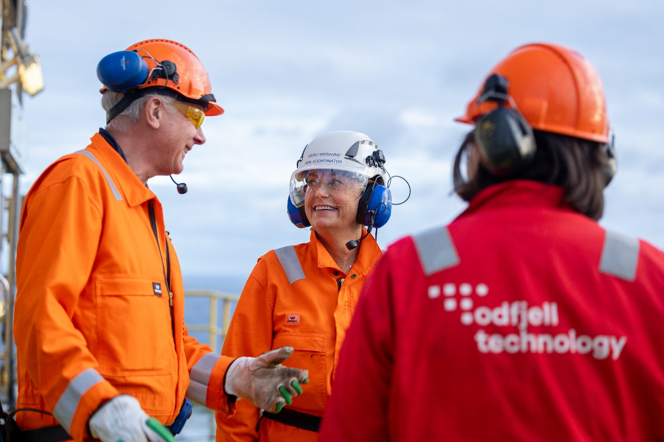

Odfjell technology (UK) Ltd
Odfjell Technology’s vision is: “Performance driven. Forward focused.” This is supported by five core corporate values that define and instruct our business, these are Committed, Safety Conscious, Creative, Competent and Result Oriented. The company vision and core values demonstrate our commitment to fostering an inclusive workplace where employees are treated fairly and have equal opportunities to succeed.

Gender Pay Gap Results
The mean (or average) is calculated by adding up the wages of all employees and dividing the figures by the number of employees.
The mean gender pay gap is the difference between mean male pay and mean female pay.
The median is the figure that falls in the middle of a range when everyone’s wages are lined up from the smallest to the largest.
The median gap is the difference between the employee in the middle of the range of male wages and the middle employee in the range of female wages.
Employee breakdown by quartile is calculated by ranking employees from the highest to the lowest paid. This is then divided into four equal parts (quartiles). The percentage of male and female are then worked out for each of the quartiles.
The gender pay gap is different from equal pay. Equal pay relates to men and women receiving the same pay for the same or equivalent work, as set out in the Equality Act 2010. Odfjell Technology is committed to ensuring equal pay for equal work and conducts reviews to support this.

Mean and median pay
Based on hourly rates from a snapshot date of 5 April 2025
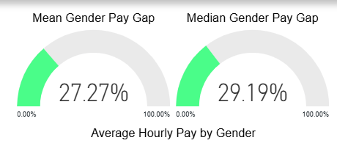
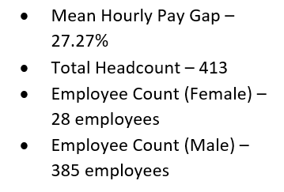

GENDER PAY GAP BONUSES

Gender Pay Gap – Bonuses (BASED ON ALL INCENTIVE PAY IN THE 12 MONTHS PERIOD TO 5 APRIL 2025)

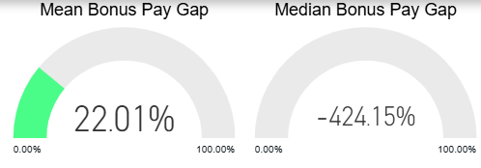
The median bonus gap of -424.15% reflects the different types, numbers and values of bonuses paid during the year, with a larger volume of bonuses payable offshore.
Proportion of females and males OF THE WORKFORCE receiving a bonus
 | Male | Female
Receiving bonus | 10.13% | 7.14%

Proportion of females and males in each quartile band
Calculations explained:
Employees are ranked from the highest to the lowest paid. This is then divided into four equal parts (quartiles). The percentage of male and female are then worked out for each of the quartiles.

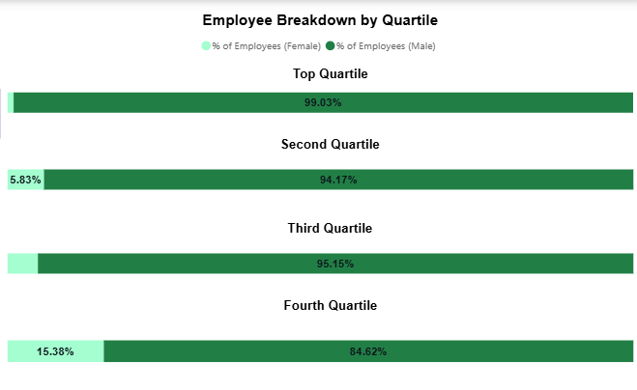

What has caused our Gender Pay Gap?
As a company operating predominantly in the oil and gas sector, a significant proportion of our workforce is based in offshore roles. While our recruitment processes are gender-neutral, the applicant pool for offshore roles is overwhelmingly male. This is evidenced by the fact that in April 2025, 93.22% of the Odfjell Technology (UK) Ltd employees were male and 6.78% female. This imbalance, combined with the higher salaries and additional bonuses paid to offshore personnel due to the offshore working environment and shift patterns, is the main reason for the higher gender pay gap when compared to other industry sectors. This is a long-term challenge across the wider oil and gas industry.

Addressing the Gender Pay Gap

Equality is an integral part of our HR Policy and Strategy that ensures that all employees are given the same opportunities for employment and pay, as well as professional development, in terms of training and promotion. We work actively and systematically through internal governing documents, employee training and various other measures to prevent any form of discrimination. Such measures include recruitment policies, salary and working conditions, personal development opportunities, promotions, and shelter against harassment.

We believe that diversity and equality are essential to be a responsible employer and bring opportunities to the group. The following are implemented and ongoing actions that will help address the gap:
- Enhanced parental leave in the UK
- Flexible working from home policy in the UK
- Women’s Network initiatives
- The Odfjell Technology Women’s Network held workshops in the UK with external guest speakers to focus on strategies to empower and support women with the company
- Employees at Prime View office were invited to attend a Menopause Awareness session

Written Statement about data provided
I confirm that the data shown in this report is accurate.
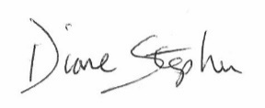
Diane Stephen
Director

